Access Guide for Theatre Works

The Deplorabes – skin of our teeth productions.

Access Notes:
- This access guide uses 14 pt in Arial font and uses 1.5 spacing.
- There are no italics but there is Bold text.
- This Access Guide has 22 pages.
- The readability level is Grade 9.
- There is only one image or photograph per page.
- Please use the Outline for Titles, Headings and subheadings to navigate through the document.

Content
Access Notes: 1
Acknowledgment of Country 3
Venue Details 4
Getting to the venue 4
Accessible Parking 5
Theatre Works Box Office Hours 7
Theatre Works Blackbox Cafe 7
Theatre Works Bar 9
Bar Menu 10
What do I wear to Theatre Works? 11
What do I bring? 11
Venue Information 12
Lighting 12
Toilets 13
How To Use The Accessible Toilet 13
Video Venue Tour 14
Birdseye Diagram of Foyer and Outside Area 15
Birdseye Diagram of Stage and Seating 16
Image of Seating Bank 17
Seating 18
Stair Rails 18
Bearded 19
Show Details 20
Accessibility 20
● Wheelchair accessible (front row of venue in space) 20
Plot 20
Structure/Form 23
Subject Warning: 23
Tech Warnings: 23
Loud Noise 24
Lighting Description 24
Set Design 24

Acknowledgment of Country

Theatre Works acknowledges First Nations’ sovereignty and recognises the continuing connection to lands, waters and communities by Traditional Owners of Country throughout Australia. We pay our respects to Aboriginal and Torres Strait Islander cultures; and to Elders past and present. We support and contribute to the process of Reconciliation.

Always was, always will be, Aboriginal land.

Theatre Works is located 14 Acland Street, St. Kilda on the stolen lands of the Boonwurrung and Woiwurrung people of the Kulin Nation. You can read about the history of Theatre Works on the website.
https://www.theatreworks.org.au

Venue Details

Getting to the venue
Theatre Works Address
14 Acland Street
St Kilda
VIC 3182
Australia

Public Transport
Theatre Works is easily reached by public transport. Tram and bus services provide regular stops and pick-ups within the Fitzroy and Acland Street shopping precincts, both just a short walk from Theatre Works.
Tram: 12 & 16
Light Rail: 96
Buses: 600 Southland Shopping Centre to St Kilda Station / 623 Glen Waverley to St Kilda Station / 246 Elsternwick to Clifton Hill.

​Parking Options
Theatre Works has two accessible parking spots available in front of the venue (pictured on the next page).

Parking can be difficult in St Kilda. We recommend arriving early and leaving yourself plenty of time for parking. Theatre Works is surrounded by permit parking so please be careful where you park. After 5pm, most car parks no longer have time restrictions.
Alternatively, you could use the paid car park at the Prince of Wales Hotel which is located on the corner of Acland and Fitzroy Streets (for access to Theatre Works).

Accessible Parking
- There are two accessible parking spots at the front of Theatre Works.
- The first image below is a photograph of where the two accessible parking lots are located.
- The second image is a screengrab of a map that shows where the two parks are located on the street from a birds eye view.
- The two pink circles mark Accessible Parking on the map. The Yellow/ Pink star marks the audience entrance to the foyer.

Image Description (Image One): A photograph of the two accessible parking spaces that lead into Theatre Works foyer.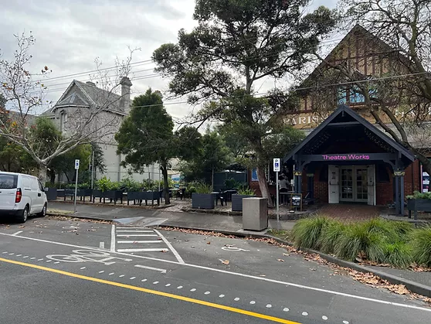
Map View
A screengrab of a map where the two accessible parks are located.
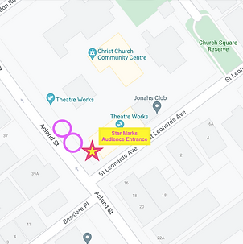
Image Description (Image 2): This is a screengrab of a map that shows where the two accessible parks are located on the street from a birds eye view. The two pink circles mark Accessible Parking on the map. The Yellow/ Pink star marks the audience entrance to the foyer.

Theatre Works Box Office Hours
The Theatre Works Box Office is open 45 minutes prior to the scheduled show start time. Come in, collect your tickets, have a drink and chat with our friendly box office crew.

Theatre Works Blackbox Cafe
Open for your daily caffeine hit and sweet treats (cakes and vegan friendly slices).
Monday to Friday, 7:30am-1:30pm
Saturday, 8am-2pm
Sunday, closed

You can order at the cafe through the open window. The cafe is cash free. You can sit inside the cafe if you would like or outside.
The image below is a photograph from inside the cafe. Meg is behind the cafe at the coffee machine. The cafe has oat milk, cows milk, soy milk and almond milk.
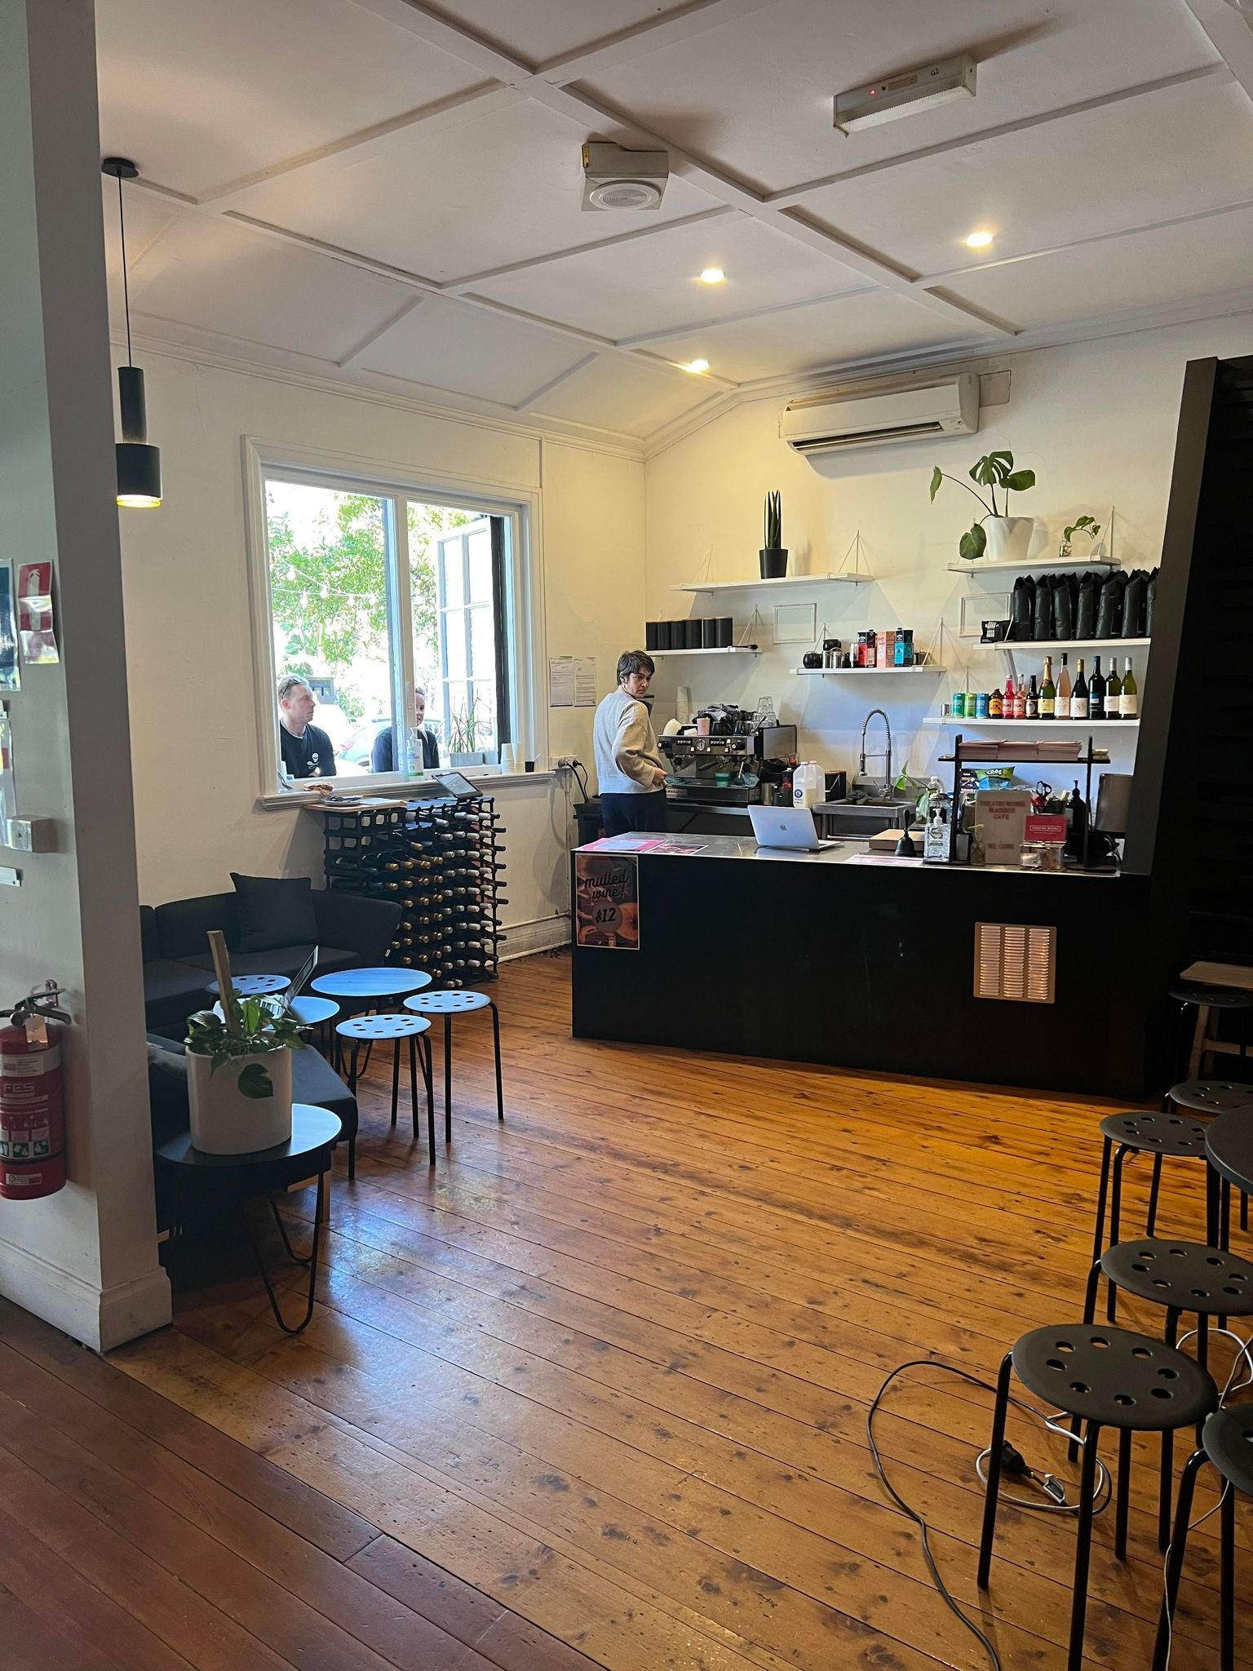
Image Description (Image 3): Meg has short, brown hair and a grey jumper. She is facing the coffee machine in the far left. There are two customers at the service window. The rest of the photograph is taken up by the wooden foyer floor and black stools.

Theatre Works Bar
- The Theatre Works bar opens one hour before the performance begins.
- Our bar is cash free which means we only accept card payments.
- We use Square pay. You can tap, swipe or insert your card. You can choose to have a receipt by clicking the receipt button.
- There will be an employee behind the bar to serve you. Sometimes they might be getting extra stock from out the back and you will need to wait a few minutes. They might say “How are you?” or “What can I get you?” and you can then tell them your order.
- There is often a queue for the bar and you will need to wait your turn.
- They will prepare your order for you.
- You are welcome to bring your drink into the theatre.
- The night time bar menu is on the next page. For special events, the bar menu may be different.

Bar Menu
Image 4: This is a copy of the bar menu used at the theatre.
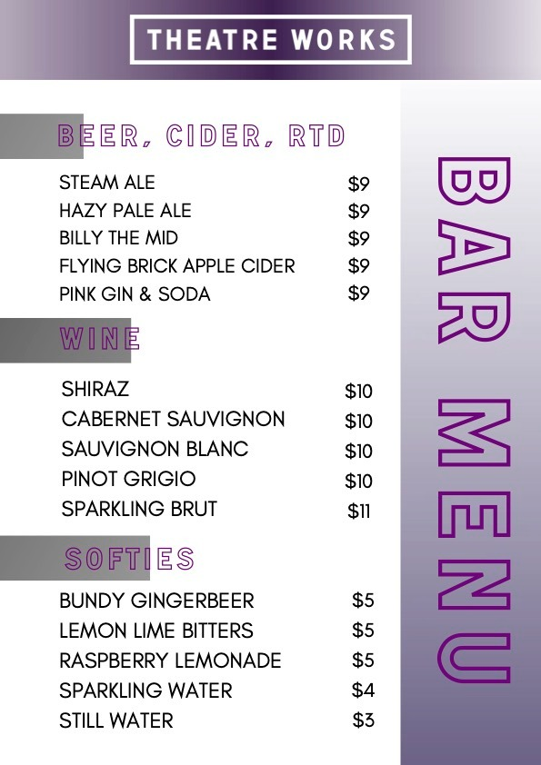

What do I wear to Theatre Works?
Casual, comfortable clothes. There is no dress code and what makes you comfortable makes us comfortable. If it’s a cold night, we would recommend wearing warm clothes.

What do I bring?
A mask is recommended. Your ticket (digital is preferred).
Assistance dogs are welcome in all venues. Fidgets if you’d like to.

Venue Information
The Theatre Works venue has been repurposed into a theatre from a church. During the day, Theatre Works runs as a cafe. During the night, Theatre Works runs as a performance venue.

Lighting
- The foyer at Theatre Works is lit by daylight from the street and warm LED lights.
- The bar at Theatre Works is lit overheard with LED lights.
- The hallway that leads to the theatre has lower lighting than the foyer and bar.
- The bathrooms are lit with fluorescent lights.
- The outside area is quite dark after sundown, with some white hanging lights for ambience.
- There are some street lights but the streets surrounding Theatre Works can be quite dark.

Toilets
- There are two bathrooms at Theatre Works. These are gender neutral.
- The toilet on the left is Accessible. There are instructions on the door.
- Click here for a video example of how to ENTER and EXIT the Accessible bathroom. The toilet door opens very slowly to ensure accessibility - please be patient.

How To Use The Accessible Toilet
- Push The Green Button To Open
- Enter The Bathroom
- Push The Black Lock Button For The Door To Close
- Wait For The Door To Close Automatically. Do Not Manually Close The Door.
- The Door Sometimes Gets Stuck, But You Can Not See Inside The Cubicle.
- Push The Green Button To Open.

Video Venue Tour
Rachel is an Associate Artist at Theatre Works. She developed her musical ‘The Dream Room’ in 2022 with Theatre Works. Rachel gives a venue tour in the youtube clip below. You can click here to see the video. There are captions in the clip.

You can click here for Rachel’s venue tour.
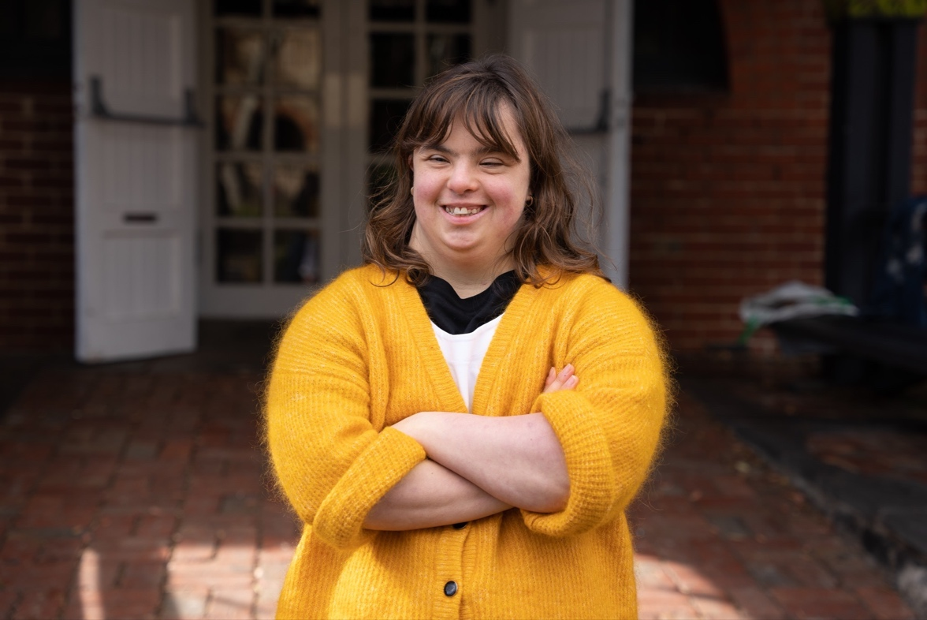
Image Description (Image 5): Rachel has brown straight hair with a fringe that ends just above her eyebrows. She has her arms crossed over her chest. She wears a fluffy mustard cardigan with a white + shirt underneath. She is smiling at the camera. There is a brick pathway behind her that leads to a brick wall and white doors.

Birdseye Diagram of Foyer and Outside Area
This diagram is not to scale but shows the structure of Theatre works.
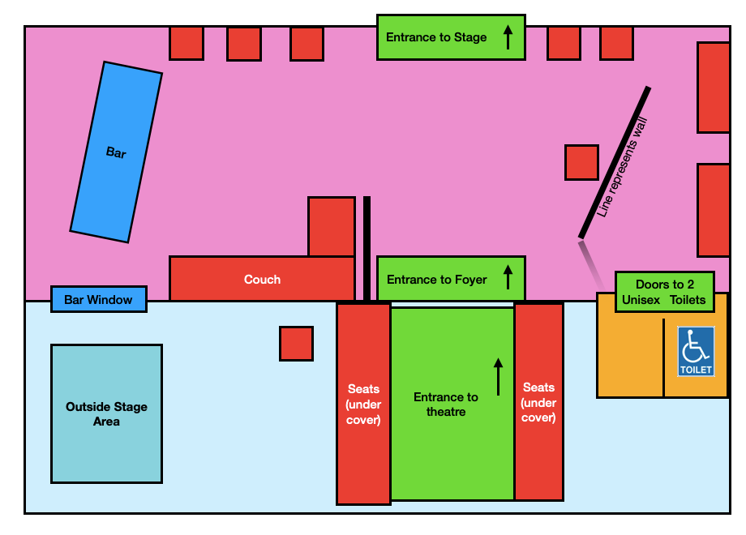Image 6: A bird's eye view of Theatre Works

Birdseye Diagram of Stage and Seating
This diagram is not in scale but demonstrates how the performance space is structured.
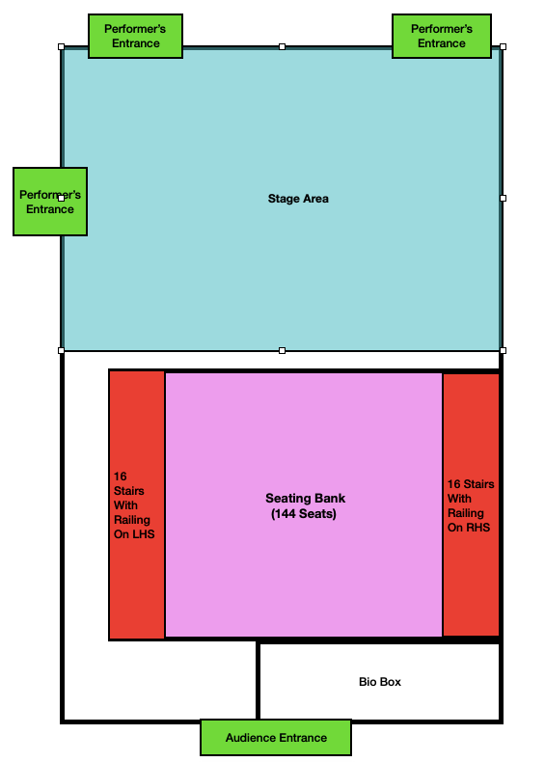
Image 7

Image of Seating Bank
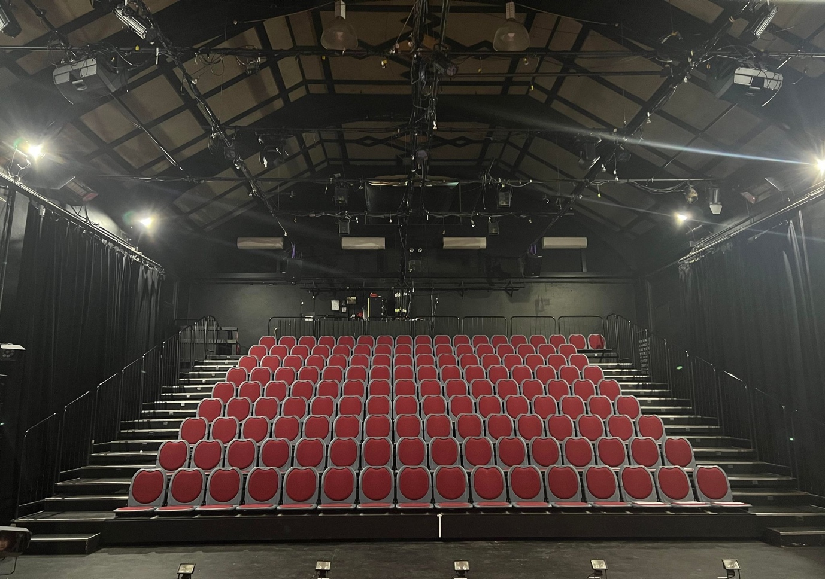
Image Description (Image 8): This is an Iphone photograph of the 144 red seats with grey sides with the house lights on. There are aisles on either side of the seats.

Seating
- There is general seating at Theatre Works. This means that there are no numbers allocated and that you can choose your own seat.
- The seats have red cushions on them with grey plastic surrounding the cushion.
- There are no armrests.
- There is no room to put bags or coats under the seats.
- The seats fold down easily.
- They sometimes make sounds when you move on them.
- There are two rails on either side of the stairs.
- You are welcome to sit wherever you prefer. If the show is sold out then you will be asked to sit in any available seat.
- If you would benefit from taking your allocated seat before other patrons enter the theatre, please let one of Theatre Works team members know, and they will happily arrange this for you.

Stair Rails
- There are 16 stairs in total to the top of the rafters.
- The stairs range from 15.5 cm to 16 cm.
- The stairs have rails that can be used for support.
- The rail sometimes makes a rattling sound when pressure is put on it but they are secure.

The Deplorables

A Theatre Works Access Guide contains in-depth details about the venue and performance. The aim of this guide is to give as much information as possible regarding each event.

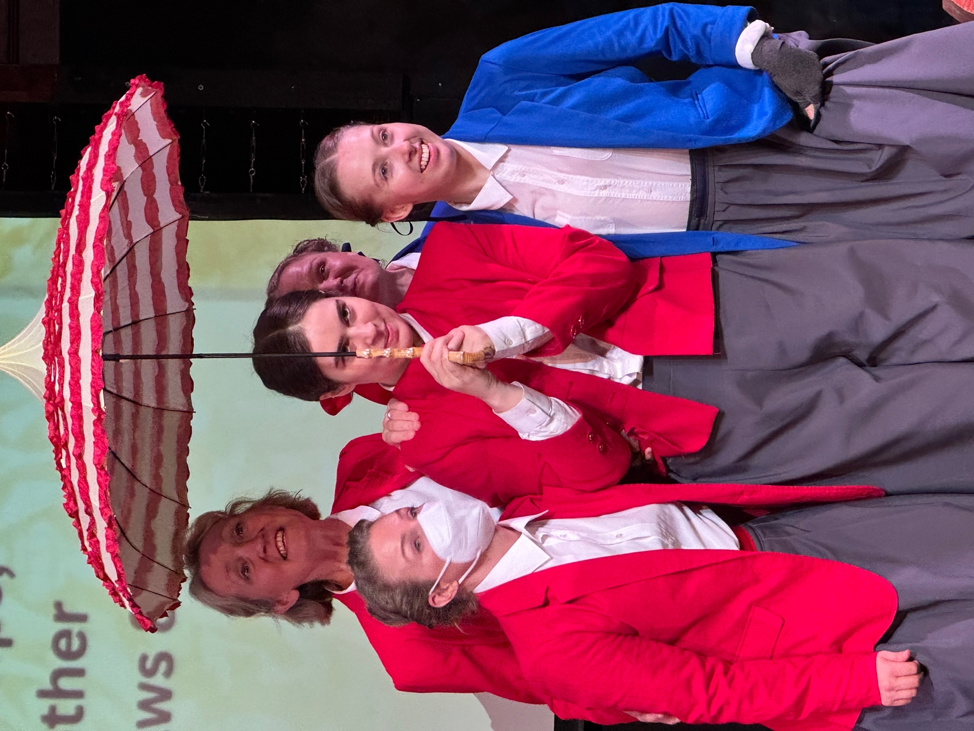
Image Description:
Five women in red and blue jackets stand centre frame, beneath a red and white umbrella. One of them wears a mask (this is a rehearsal shot). The women are happy and animated. In the background is a projection screen.

Show Details
- 70 minutes with no interval.

Accessibility
- Wheelchair accessible (front row of venue in space)
- Soft earplugs available at bar
- Some fidgets available at the bar
- Tuesday 25th performance is Auslan interpreted.

Plot
- The Deplorables is the story of the first women’s cricket match in Australia – at Bendigo, 1874. Much of the story of the game and the women has been lost to history, so we have recreated the match, the outcome and the outcry from the press from scant records and imagination. The story is uplifting because of the women’s efforts, rage-making because the press told them to go home and shut up, and ultimately hopeful.

Structure/Form
- Musical, magic realist, non-naturalistic.

Subject Warning:
- No subject warnings.

Tech Warnings:
- No tech warnings.

Loud Noise
- The performers in the Deplorables sing and there are loud moments of dialogue.
- There are sound effects of heart beats and bells.

Lighting Description
- The Deplorabes has moments of heightened drama and tension accentuated by lighting, including blackouts.

Set Design
- The Deplorables set is made up of four nests of props that hang from the ceiling – creating a central space. There are four platforms for performers to stand on, and three dress makers’ dummies.

IMAGE OF SET
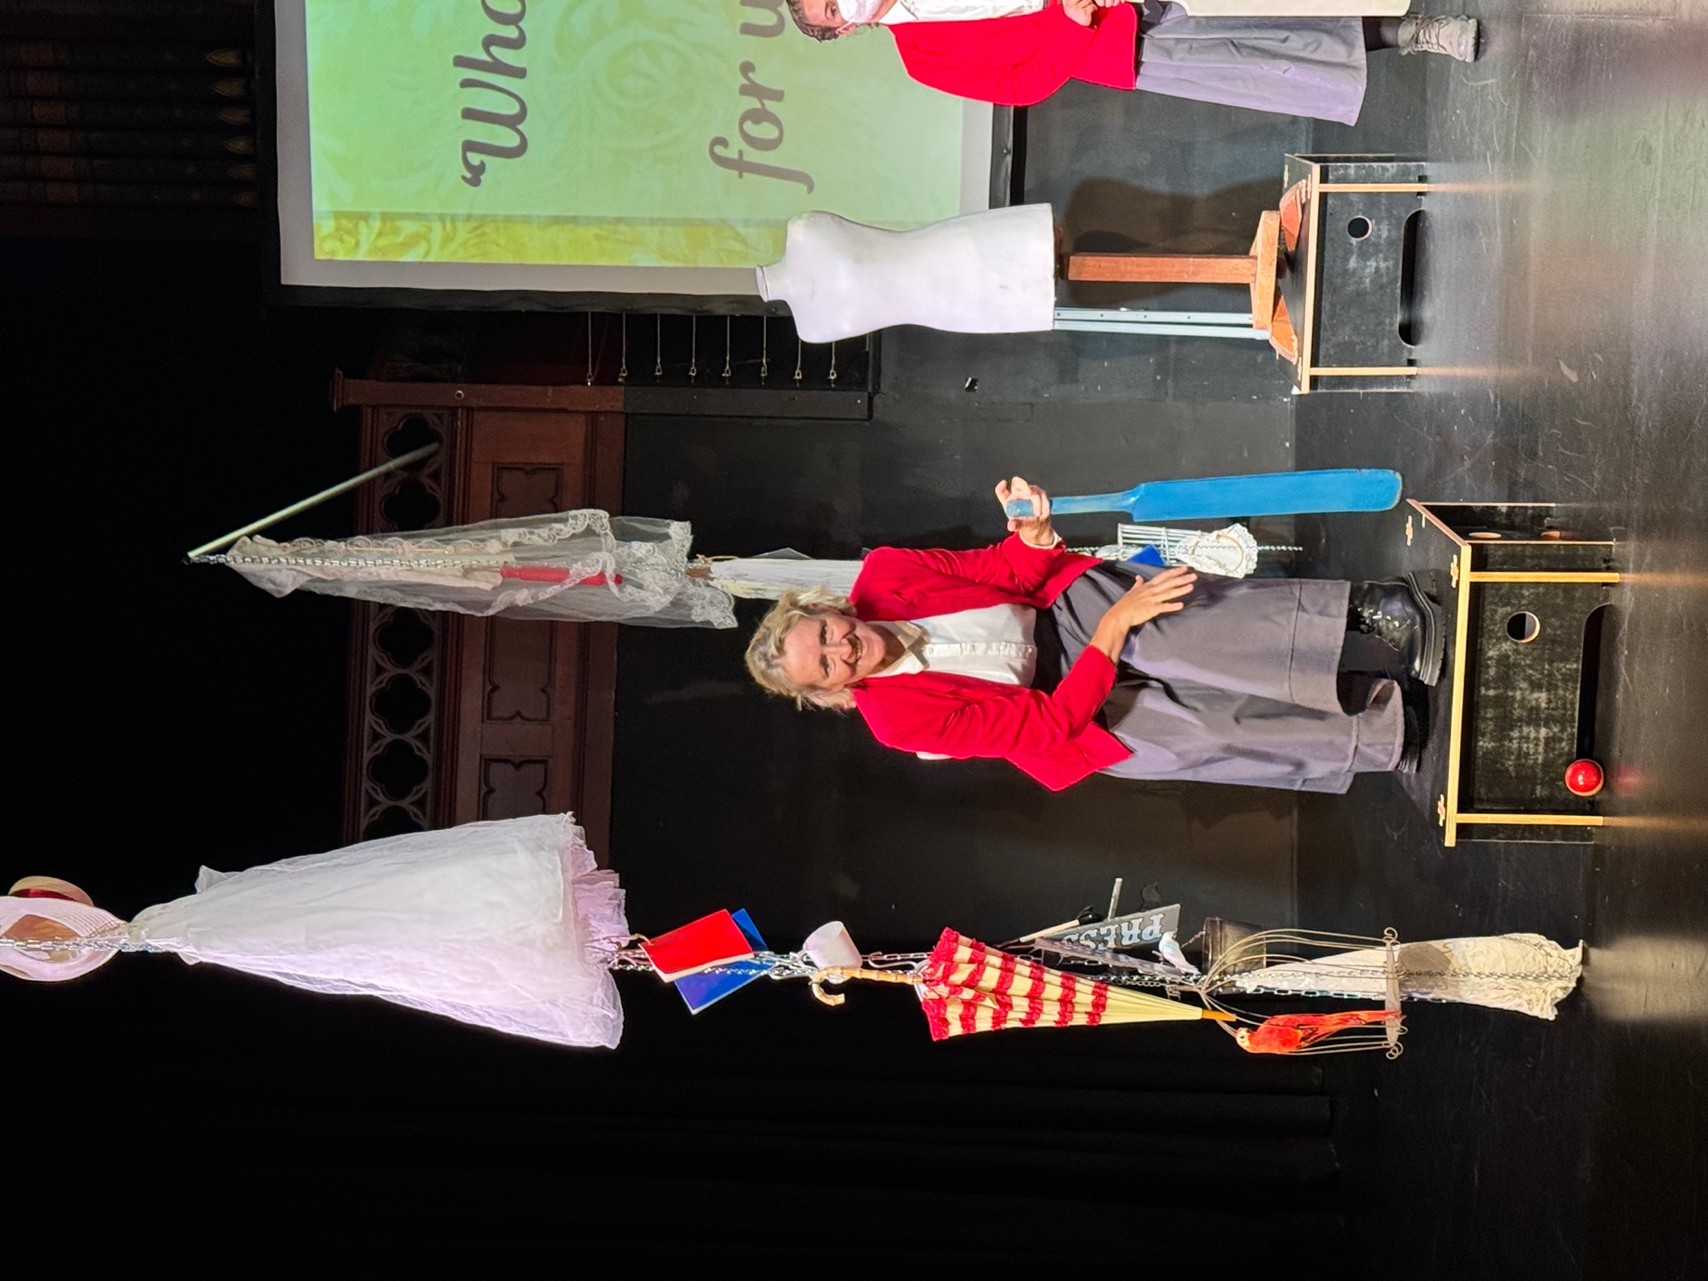

IF YOU HAVE ANY FURTHER QUESTIONS - PLEASE FEEL FREE TO EMAIL COMMUNICATIONS@THEATREWORKS.ORG.AU FOR CLARITY

